C++ Theory Exercises

- Introduction to C++

- What are the key differences between Procedural Programming and Object-Oriented Programming (OOP)?

Procedural Programming | Object-Oriented Programming
The program is divided into small parts and it is called a function. | The program is divided into small parts and it is called object.
It follows a top-down approach. | It follows a bottom-up approach.
This language has no access specifier. | This language has three access specifiers like public, private and protected.
Adding new data and functions is not easy. | Adding new data and functions is easy in this language.
Less secure as data is globally accessible. | More secure due to encapsulation and data hiding,
Overloading is ot possible in POP | Overloading is possible in OOP
Data and functions are separate | Data and functions are combined in objects
Limited reusability of code. | High reusability of code using inheritance.
Functions can access global data freely. | Data is accessed through methods
Difficult to maintain large programs. | Easier to maintain and modify.
Harder to debug in large programs. | Easier to debug due to modular structure.
Ex : C, Pascal | Ex : C++, Java, Python

- List and explain the main advantages of OOP over POP.
  - Object-Oriented Programming provides several benefits compared to Procedural Programming, especially for large and complex applications. The main advantages are:

Encapsulation (Data Hiding) : OOP combines data and functions into a single unit called an object. Data is hidden from outside access and can only be accessed through methods, which increases security and prevents misuse.

Reusability : OOP supports inheritance, which allows one class to reuse the properties and methods of another class. This reduces code duplication and saves development time

Modularity : Programs are divided into smaller parts called classes. Each class handles a specific task, making the program well-organized and easier to understand.

Flexibility (Polymorphism) : OOP allows one function or method to behave in different ways using polymorphism. This makes programs more flexible and adaptable.

Easy Maintenance : Because of its modular structure, OOP programs are easier to update, modify, and fix without affecting the entire system.

Improved Security : Using access specifiers like private, public, and protected, OOP restricts unauthorized access to data, making programs more secure than POP.

Real-world Modeling : OOP models real-world entities (like objects such as car, student, etc.), making it easier to design and understand complex systems.

Code Manageability : Large programs can be handled efficiently since OOP organizes code into manageable objects and classes.

- Explain the steps involved in setting up a C++ development environment.
  - Install a C++ compiler (such as GCC or MinGW).
  - Install an IDE (such as Dev-C++ or Code::Blocks).
  - Configure the compiler in the IDE settings.
  - Create a new C++ program file.
  - Write the C++ code.
  - Compile the program.
  - Run the program.

- What are the main input/output operations in C++? Provide examples.
  - Output Operation (cout) :
    - Used to display output on the screen.
    - Insertion operator <<
Ex :
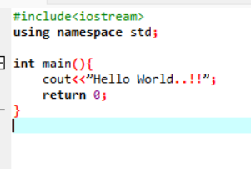

  - Input Operation(cin) :
    - Used to take input from the user
    - Extraction operator >>
Ex :
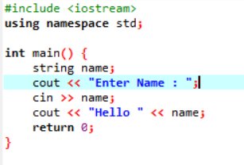

  - Error Output(cerr) :
    - Used to display an error message
Ex :
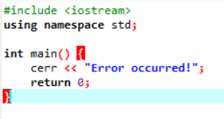

  - Log Output(clog) :
    - Used to display logging messages
Ex :
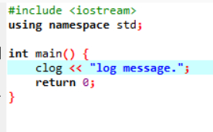

- Variables, Data Types, and Operators

- What are the different data types available in C++? Explain with examples.
C++ provides several types of data types, which can be grouped into basic (primitive), derived, and user-defined data types.
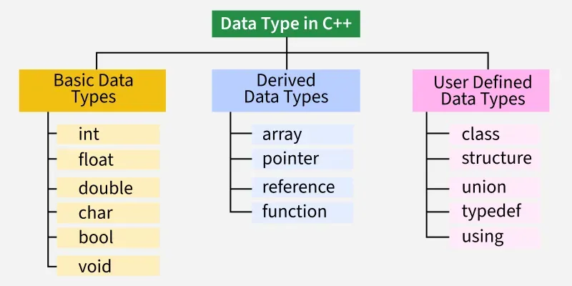
  - Basic(Primitive) Data Types :
    - Integer Types
- Used to store whole numbers.

int → stores integers
short int → smaller range than int
long int → larger range than int
Ex :
int a = 10;
long int b = 100000;

    - Float Types
- Used to store decimal numbers.

float → single precision
double → double precision
Ex :
float x = 5.5;
double y = 10.12345;

    - Char Type :
- Used to store a single character.
- stores characters enclosed in single quotes (' ')
- generally store upto 256 characters according to their ASCII codes.
Ex :
char c = 'A';

    - Boolean Type :
- Used to store true or false values.
- true(1) or false(0)
Ex :
Bool isTrue = true;
    - Void Type :
- void data type represents the absence of value.
- used for pointers and functions that do not return any value using the keyword void.
Ex :
void display() {
// no return value
}
- Explain the difference between implicit and explicit type conversion in C++.
Implicit Type Conversion | Explicit Type Conversion
An implicit type conversion is automatically performed by the compiler when differing data types are intermixed in an expression. | An explicit type conversion is a user-defined conversion that forces an expression to be of a specific type.
An implicit type conversion is performed without the programmer's intervention. | An explicit type conversion is specified by the programmer.
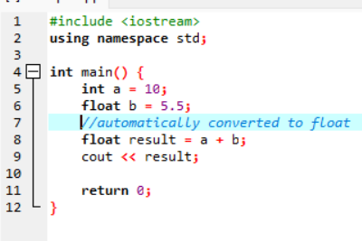 | 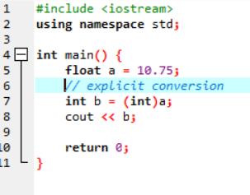

- What are the different types of operators in C++? Provide examples of each?
  - Arithmetic Operators :
These operators are used to perform arithmetical and mathematical operations on the operands.
    - Addition, +, Adds two operands
    - Subtraction, -, Subtracts second operand from the first
    - Multiplication, *, Multiplies two operands
    - Division, /, Divides first operand by the second operand
    - Modulo Operation, %, Returns the remainder of an integer division
    - Increment, ++, Increases the value of operand by 1
    - Decrement, --, Decreases the value of operand by 1
Ex :
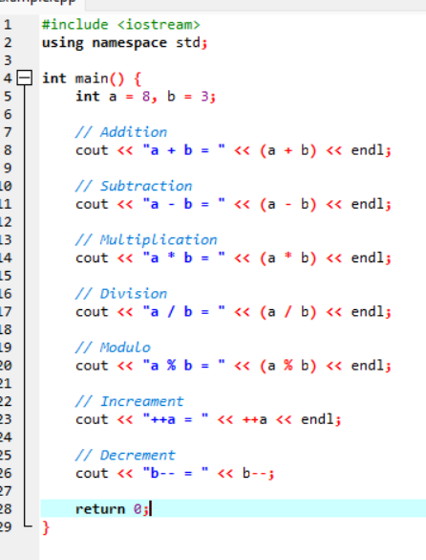
  - Relational Operators :
These operators are used for the comparison of the values of two operands.
    - Is Equal To, ==, Checks if both operands are equal
    - Greater Than, >, Checks if the first operand is greater than the second operand
    - Greater Than or Equal To, >=, Checks if the first operand is greater than or equal to the second operand
    - Less Than, <, Checks if the first operand is lesser than the second operand
    - Less Than or Equal To, <=, Checks if the first operand is lesser than or equal to the second operand
    - Not Equal To, !=, Checks if both operands are not equal
Ex :
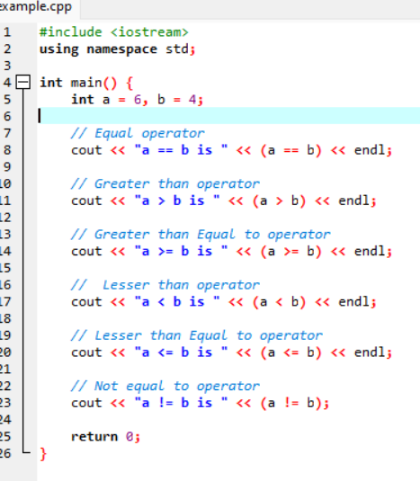
  - Logical Operators :
These operators are used to combine two or more conditions or constraints or to complement the evaluation of the original condition in consideration. It returns a Boolean Value.
    - Logical AND(&&): Returns true only if all the operands are true or non-zero
    - Logical OR(||) Returns true if either of the operands is true or non-zero
    - Logical NOT (!):: Returns true if the operand is false or zero
Ex :
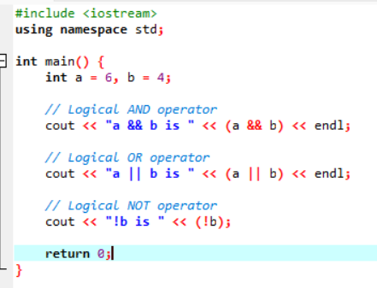

  - Bitwise Operators :
These operators work on the bit level. So the compiler first converts to bit-level and then the calculation is performed on the operands.
    - Binary AND, &, Copies a bit to the result if it exists in both operands
    - Binary OR, |, Copies a bit to the result if it exists in any of the operands
    - Binary XOR, ^, Copies the bit to the result if it is present in either of the operands but not both
    - Left Shift, <<, Shifts the value to the left by the number of bits specified by the right operand
    - Right Shift, >>, Shifts the value to the right by the number of bits specified by the right operand
    - One's Complement, ~, Changes binary digits 1 to 0 and 0 to 1
Ex :
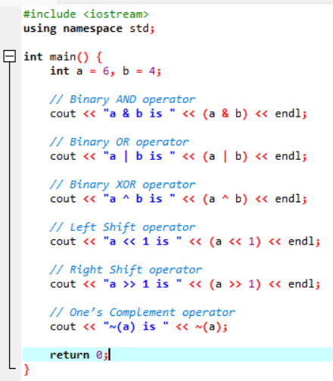
  - Assignment Operators :
This operators are used to assign value to a variable. We assign the value of right operand into left operand according to which assignment operator we use.
    - Assignment ( = ) : Assigns the value on the right to the variable on the left
    - Add and Assignment ( += ) Adds the right operand to the left operand and assigns the result to the left operand
    - Subtract and Assignment ( -= ) : Subtracts the right operand from the left operand and assigns the result to the left operand
    - Multiply and Assignment ( *= ) : Multiplies the left operand by the right operand and assigns the result to the left operand
    - Divide and Assignment ( /= ) : Divides the left operand by the right operand and assigns the result to the left operand
Ex :
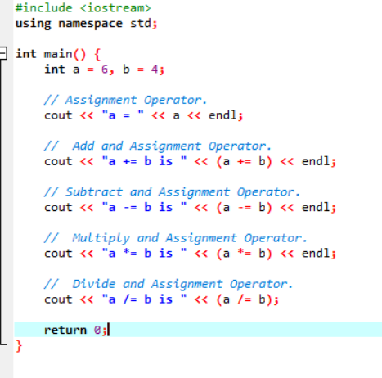
  - Ternary or Conditional Operators
Conditional operator returns the value, based on the condition. This operator takes three operands, therefore it is known as a Ternary Operator.
Syntax :
Expression1 ? Expression2 : Expression3
- The ternary operator ? determines the answer on the basis of the evaluation of Expression1.
- If Expression1 is true, then Expression2 gets evaluated.
- If Expression1 is false, then Expression3 gets evaluated.
Ex :
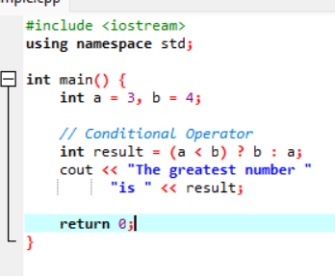

- Explain the purpose and use of constants and literals in C++.
  - Constants :
    - Constants are fixed values that cannot be changed during program execution.
    - Used to store values that should remain constant, improving code safety and readability.
Ex :
const int MAX = 100;
Purpose:
Prevent accidental modification and make programs more reliable
  - Literals :
    - Literals are actual values directly written in the code.
    - Examples: 10, 3.14, 'A', "Hello"
    - Types include integer, floating-point, character, and string literals.
Purpose:
Represent fixed values used in expressions.
.
- Control Flow Statements

- What are the key differences between Procedural Programming and Object-Oriented Programming (OOP)?
  - Conditional statements are used to make decisions in a program based on conditions (true or false). They control the flow of execution.
If-Else Statement:
Used to execute code based on a condition.
If the condition is true, if block runs; otherwise, else block runs.
Syntax :
If (condition) {
//if condition is true
} else {
//if code is false
}

Example :
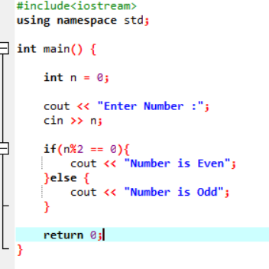
Switch Statement:
Used to select one block of code from multiple options.
Works with integer or character values.
Syntax :
switch (expression) {
case value1:
// code
break;
case value2:
// code
break;
default:
// code if no match
}
Example :
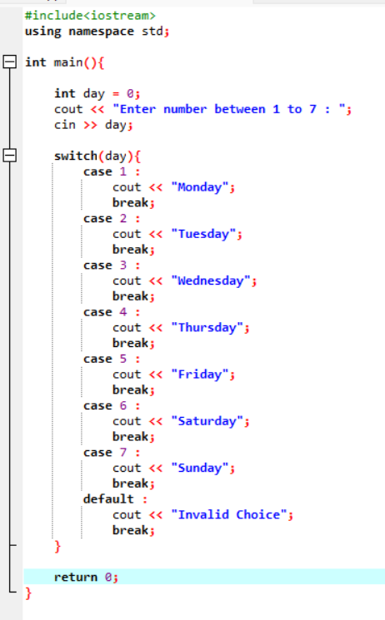
- What is the difference between for, while, and do-while loops in C++?
  - for → best for fixed number of iterations
  - while → condition checked first
  - do-while → executes at least once always

Feature | For Loop | While Loop | Do-While Loop
Condition check | Before loop | Before loop | After loop
Exceution | May run 0 times | May run 0 times | Run at least once
Use | When iterations are known | Condition based | Loop must run once
Syntax | for (initialization; condition; increment/decrement) {  // statements  } | while (condition) {  // statements  } | do {  // statements  } while (condition);
Example 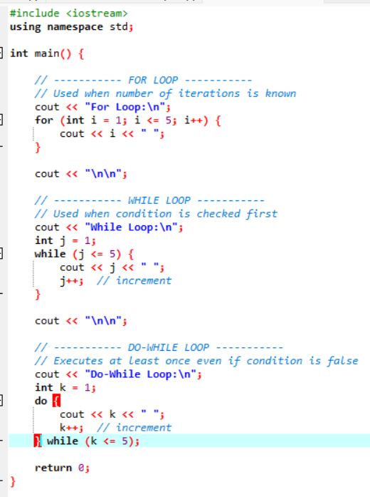
- How are break and continue statements used in loops? Provide examples.
  - Break Statements :
    - Used to exit the loop immediately.
    - Control goes to the next statement after the loop.

Ex :
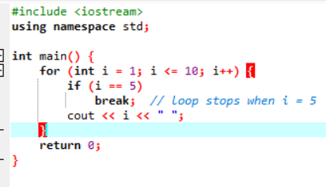
  - Continue Statement :
    - Used to skip the current iteration and move to the next iteration.
Ex:
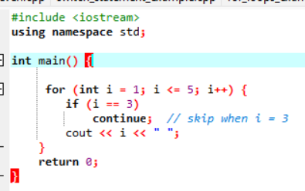

- Explain nested control structures with an example.
  - Nested control structures mean placing one control statement inside another, such as loops inside loops or if inside if.

Purpose:
Used to handle more complex conditions or repeated tasks.
Syntax :
if (condition1) {
if (condition2) {
// statements
}
}
Example :
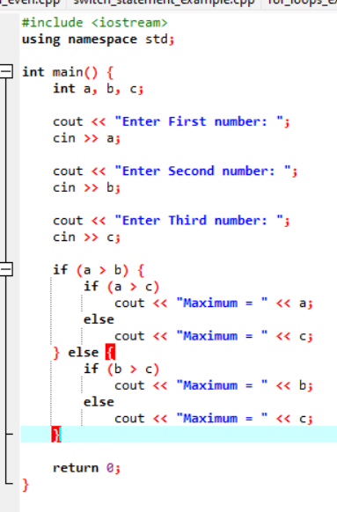

- Functions and Scope

- What is a function in C++? Explain the concept of function declaration, definition, and calling.
  - A function is a block of code that performs a specific task. It helps break a large program into smaller, manageable pieces — promoting reusability, readability, and modularity.

Parts of function :
- Function Declaration (Prototype)
  - A declaration tells the compiler about a function's name, return type, and parameters — before it's actually defined. This is needed when the function is defined after main().
Syntax :
returnType functionName(parameterType1, parameterType2);
- Function Definition
  - The definition contains the actual body of the function — the code that runs when the function is called.
Syntax :
returnType functionName(parameterType param1, parameterType param2) {
// body
return value;
}

- Function Call :
  - A call is how you execute the function. You pass arguments, and the function returns a result (if it has a return type).
Syntax :
functionName(arg1, arg2);
Ex :
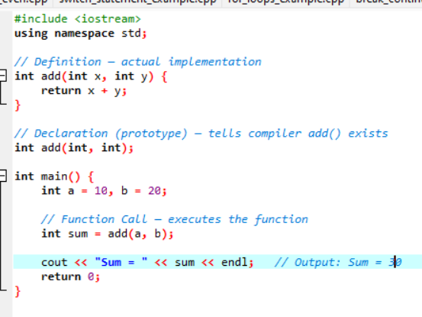
- What is the scope of variables in C++? Differentiate between local and global scope.
  - Scope refers to the region of a program where a variable is accessible (visible and usable). Outside its scope, the variable simply doesn't exist or can't be accessed.
  - Two types of Scope :
    - Global Scope
    - Local Scope

Feature | Local Scope | Global Scope
Declaration | Inside Function | Outside function
Accessibility | Only with that block or code | Entire Program
Validity | Exist during function call | Exis throughout the program

- Explain recursion in C++ with an example.
  - Recursion is a programming technique where a function calls itself repeatedly until a specific base condition is met. A function that performs such self-calling behavior is known as a recursive function, and each instance of the function calling itself is called a recursive call.
Ex :
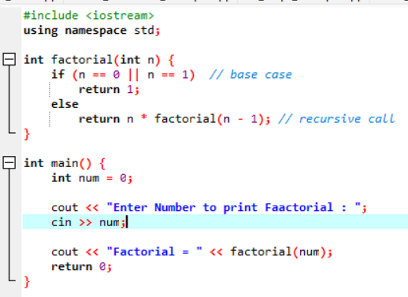
- What are function prototypes in C++? Why are they used?
  - Function prototype is a statement that tells the compiler about the function’s name, its return type, numbers, and data types of its parameters.
Syntax :
return_type name(type1, type2 ....);
Why are they used ?
- Informs the compiler about the function before it's defined, avoiding "function not declared" errors.
- Allows main() to appear first, with definitions below it.
- Enables error checking — compiler verifies correct argument types and count at every call.
- Supports multi-file programs — prototypes in header files (.h) let functions be shared across files.

- Arrays & Strings

- What are arrays in C++? Explain the difference between single-dimensional and multi-dimensional arrays.
  - An array is a collection of elements of the same data type stored in contiguous memory locations, accessed using an index.
Ex :
int marks[5] = {90, 85, 78, 92, 88};
// ↑ size ↑ elements
- Single-Dimensional Array (1D) :
  - Stores elements in a single row
  - Accessed using one index
Syntax :
dataType arrayName[size];
Example :
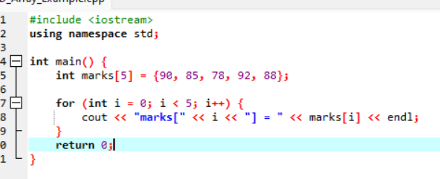
- Multi-Dimensional Array :
  - An array of arrays — the most common being the 2D array, which represents a table/matrix with rows and columns.
Syntax :
dataType arrayName[rows][cols];
Example :
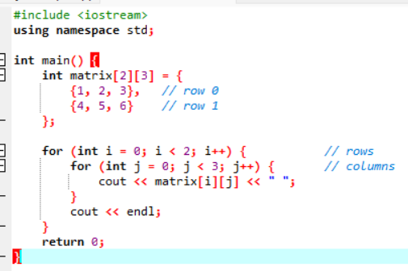
- Explain string handling in C++ with examples
  - In C++, strings are used to store and manipulate text. There are two main ways:
    - C-style strings (character arrays)
      - Stored as character arrays ending with '\0'
Syntax :
char name[] = "Hello";
Example :
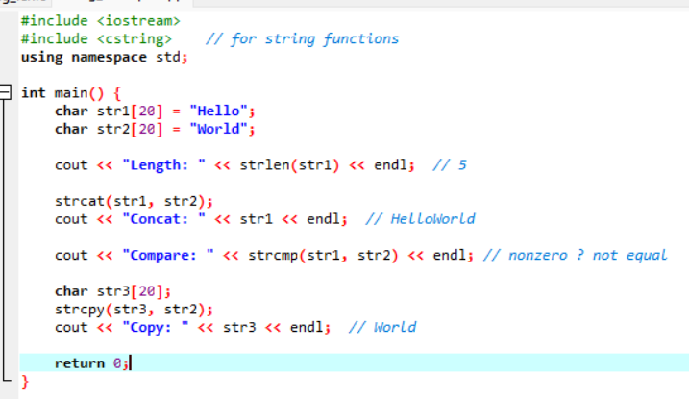
    - string class (from Standard Library) :
      - Easier and more powerful (from <string> library)
Example::
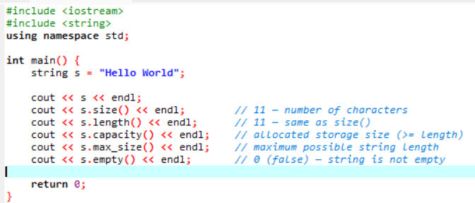
- How are arrays initialized in C++? Provide examples of both 1D and 2D arrays.
  - Arrays can be initialized at the time of declaration in different ways depending on the type and dimension.
- Single-Dimension Array Initialization (1D Array) :
  - Method 1: Initialize the values
Ex :
int arr[5] = {1, 2, 3, 4, 5};
  - Method 2: Size omitted (compiler counts elements)
Ex :
int arr[] = {10, 20, 30, 40};
  - Method 3: Partial initialization (remaining = 0)
Ex :
int arr[5] = {1, 2};
// Output: 1 2 0 0 0
  - Method 4: Initialize all elements with 0
Ex :
int arr[5] = {0};
- Multi-Dimensional Array Initialization (2D Array) :
  - Method 1: Row-wise initialization
Ex :
int matrix[2][3] = {
{1, 2, 3},
{4, 5, 6}
}
  - Method 2: Without inner braces
Ex:
nt matrix[2][3] = {1, 2, 3, 4, 5, 6};

  - Method 3: Partial initialization
Ex :
int matrix[2][3] = {
{1, 2},
{3}
};
// Output:
// 1 2 0
// 3 0 0

  - Method 4: Initialize all elements to 0
Ex :
int matrix[2][3] = {0};

Example :
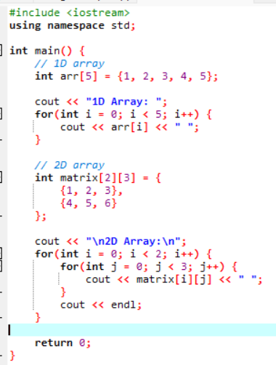

- Explain string operations and functions in C++.

  - String Declaration and String Class :
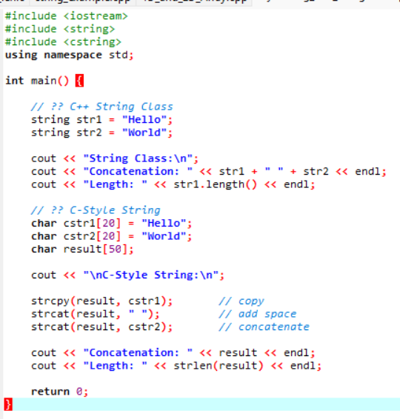
  - Common String Operations
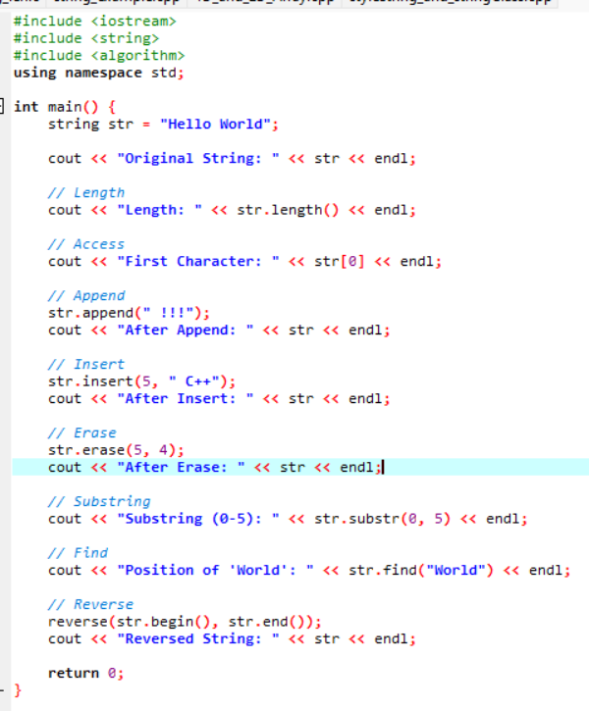
- Introduction to Object-Oriented Programming
- Explain the key concepts of Object-Oriented Programming (OOP).
  - Object-Oriented Programming (OOP) is a programming paradigm that organizes software design around objects—data structures that combine state (attributes) and behavior (methods) to represent real-world entities.
The main 4 pillars of OOPS are described below
- Encapsulation:
  - Encapsulation means binding data and functions together in a single unit (class) and restricting direct access to data using access specifiers (private, public, protected).
Ex :
class BankAccount {
private:
double balance;
public:
void deposit(double amount) {
balance += amount;
}
};

- Inheritance :
  - Inheritance allows a class (child/derived) to acquire properties and behavior of another class (parent/base). It promotes code reuse.
  - Types of Inheritance :
    - Single Inheritance
    - Multiple Inheritance
    - Multi-level Inheritance
    - Hybrid Inheritance
    - Hierarchical Inheritance
Ex :
class Animal {
public:
void eat() {
cout << "Eating";
}
};

class Dog : public Animal {
public:
void bark() {
cout << "Barking";
}
};

- Polymorphism :
  - Polymorphism means one function, multiple forms.
  - Types of polymorphism: :
  - Compile-time (Function Overloading)
  - Run-time (Function Overriding)
Ex :
int add(int a, int b) {
return a + b;
}

double add(double a, double b) {
return a + b;
}

- Abstraction :
  - Abstraction means hiding internal implementation details and showing only essential features to the user.
Ex :
class Shape {
public:
virtual void draw() = 0; // abstract function
};
- What are classes and objects in C++? Provide an example.
  - Class :
- A class is a user-defined data type that acts as a blueprint for creating objects. It contains:
  - Data members (variables)
  - Member functions (functions)
- It defines the structure and behavior but does not occupy memory until objects are created.
  - Object :
- An object is an instance of a class. It represents a real-world entity and is used to access the data and functions defined in the class.
Ex :
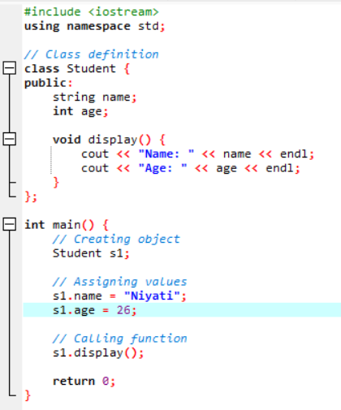
- What is inheritance in C++? Explain with an example.
  - Inheritance is an OOP concept where one class (called the derived/child class) acquires the properties and behaviors of another class (called the base/parent class).
  - Types of Inheritance in C++
    - Single Inheritance – One base → One derived
    - Multiple Inheritance – Multiple base → One derived
    - Multilevel Inheritance – Chain of inheritance
    - Hierarchical Inheritance – One base → Multiple derived
    - Hybrid Inheritance – Combination of above
  - It helps in
    - Code reusability
    - Reducing duplication
    - Creating hierarchical relationships
Syntax :
class DerivedClass : access_specifier BaseClass {
// body
}
;
Example :
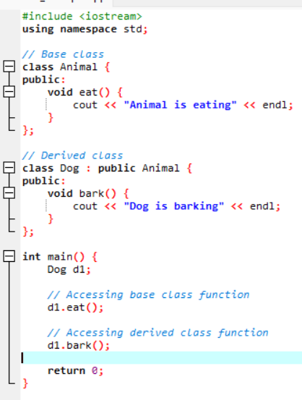

- What is encapsulation in C++? How is it achieved in classes?
  - Encapsulation is an OOP concept that means wrapping data (variables) and functions (methods) together into a single unit, i.e., a class, and restricting direct access to the data.
  - It helps in:
    - Data hiding
    - Security
    - Controlled access
  - Encapsulation is achieved in C++ using:
- Access Specifiers
  - private → Data cannot be accessed directly from outside the class
  - public → Data/functions can be accessed from outside
  - protected → Accessible within class and derived classes
- Getter and Setter Functions
  - Used to read (get) and update (set) private data safely

Ex :
